
BC Hands & Voices
3rdAnnual Spring Picnic
An opportunity to meet other families with
children who are deaf or hard of hearing, ages 0-5.
Saturday, May 28th
11:00 am to 2:00 pm

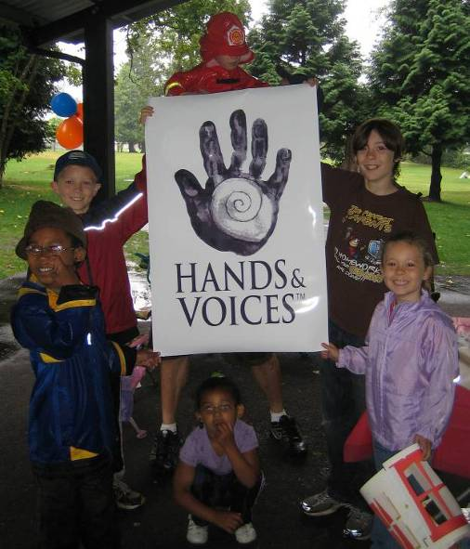
Clayton Community Hall (on 70th Avenue near 184th Street in Surrey)
(See map below for details)

Meet at the shelter near the playground – look for the blue & orange balloons!

- Bring the whole family and a potluck dish to share (beverages will be provided).
- Don’t forget your blankets & lawn chairs. We will move into the hall in case of rain.
- Fun for the kids! Face painting, crafts, parachute games, races & playground.
DO YOU LIVE OUTSIDE THE LOWER MAINLAND?
We have a grant from BC Children’s Hospital to help pay your travel expenses to come to our event! It will not cover flights, but would certainly help with ferry fares, gas, etc. Please contact us to find out more details! ☺

Please RSVP by Wednesday, May 25th to info@bchandsandvoices.com
or phone 604 552-2254

Please include your names, the age(s) of your child/children, and what you would like to bring.
For more info about BC Hands & Voices go to www.bchandsandvoices.com

What works for your child is what makes the choice right.
Google maps link: http://goo.gl/maps/gE4d



